Scripture
"And Isaac digged again the wells of water, which they had digged in the days of Abraham his father; for the Philistines had stopped them after the death of Abraham: and he called their names after the names by which his father had called."(KJV)

Thought for Today
“Isaac reopened the wells that had been dug in the time of his father Abraham, which the Philistines had stopped up after Abraham died.” Genesis 26:18 (NIV)

Isaac was a desert dweller living in the Judean wilderness south of Bethlehem. Survival there without water was a matter of hours. Many years before, Isaac’s father had dug vital wells, but the enemies of the family had since filled them with dirt. To live, he had to reestablish the wells of his father. This was his top priority.

We need to reestablish many of the wells our forefathers dug in order to survive spiritually. The well of fervent prayer is the most important. It is the divinely devised means of releasing God’s heavenly power upon the earth. It is the mightiest force on the planet, yet it is also the most neglected ministry today. Satan will do everything he can to fill in the believer’s well of prayer. There is no wonder!! Prayer binds Satan and shackles his bands of hellish demons. Prayer unleashes the power of almighty God to intervene in the affairs of men. Jesus never taught men to sing or preach or organize, but He did take time to teach them to pray.

There are five principles of prayer. First, is the principle of right relationship. David wrote in Psalm 66:18, “If I regard iniquity in my heart, the Lord will not hear me.” When you pray, are you harboring known sins in your life? Do you hold a grudge? Do you have an unforgiving or un-Christ like spirit? The person who has improper relationships may think he is praying, but in reality he is only going through the motions.

The second is the principle of priority. If we think we can work out our own problems, solve our own difficulties, and take care of our own needs, we reduce God to a third or fourth position in our lives. We must remember that God is our refuge, and that “it is not by might, nor by power, but by My Spirit saith the Lord” (Zech. 4:6).

Third, is the principle of prayer in Jesus’ name. Jesus said, “Whatsoever ye shall ask in my name, that will I do” (John 14:13). Here is a thought to remember: Jesus has given us a verbal and written authorization, recognized as power of attorney, to use His name. The power of attorney means the legal right given to one person to act in place of another. In other words, when we use the name of Jesus in prayer we are backed up by all that God is and all that God has. That does not mean we pray for things that are inconsistent with our living for the Lord. It does mean we can come boldly before His throne, in Jesus’ name, asking for those things we have need of.

The fourth principle is that of proper living. The prayer life of a person cannot be much different than the condition of his daily walk with God. The Bible says we are to pray in the Spirit, but if our personal lives are not spiritual, we cannot pray spiritual prayers.

The fifth is the principle of praise and thanksgiving (Psalms 100:4). There is a difference between thanksgiving and praise. Thanksgiving is basically gratitude for what God has done for us. Praise is our adoration directed to God for who He is – not what He has done. Prayer is not complete without the twin offering of thanksgiving and praise. 1 Thess. 5:18 says, “In everything give thanks: for this is the will of God in Christ Jesus concerning you.”

Isaac redug the wells of his father. More than anything else, what thrust our fathers to victory was prayer: fervent supplication and praise to the Lord. That well must be re-opened. Check your priorities. Have you taken time to pray during your busy day? If you are too busy to pray, then you are much, much to busy. Martin Luther said, “If I neglect prayer but a single day, I should lose a great deal of the fire of faith.” Isaac re-dug the wells of his father. Let us do the same.

Prayer
“Dear heavenly Father: Help me to dig the dirt out of my well of prayer. The cares, the demands, the expectations, and the stress of life have unconsciously filled in my prayer well. Let the cool waters of the Holy Spirit come and quench this deep thirst in my soul. I desperately need it! Amen.”

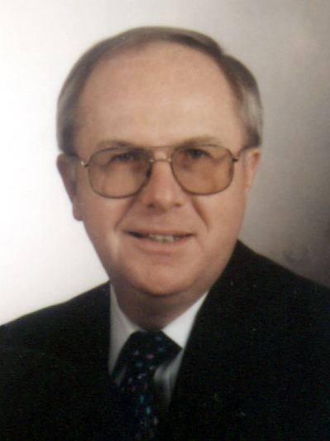 | Meet the Author  Paul D. Gibbon and his wife Joan pastored for 36 years with the Pentecostal Assemblies of NL. During this time, They ministered at Emmanuel Pentecostal Church, Deer Lake, Evangel Pentecostal Tabernacle, Grand Falls, and Glad Tidings Tabernacle, Embree . He spent many years in Youth Ministry. Paul and Joan are now semi- retired. They continue to minister on weekends and special occasions as well as pulpit supply. They may be reached by e-mail at paulandjoan37@hotmail.com

